Q1) What is stream class and write types of strem

stream can be defined as a sequence of data. There are two kinds of Streams −
- InPutStream − The InputStream is used to read data from a source.
- OutPutStream − The OutputStream is used for writing data to a destination.
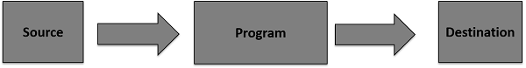

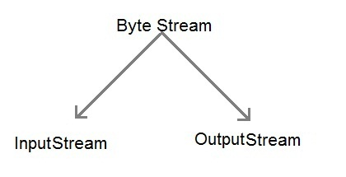
Types of stream
- Byte Stream : It provides a convenient means for handling input and output of byte.

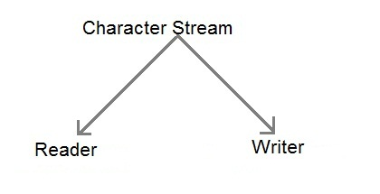
- Character Stream : It provides a convenient means for handling input and output of characters. Character stream uses Unicode and therefore can be internationalized.

Q2) write how files and stream works?

Java uses streams to handle I/O process. Input stream can flow data from a disk file to internal memory and output stream can flow data from internal file to a disk file. Disk file can be a text file or binary file. For text file character stream is used and for binary file binary stream is used.

InputStream
Flow of data

Disk-File
Internal Memory

Flow of data

Outputstream

Q3) Write a java program to read a text file in java.
- import java.io.FileReader;
- public class FileReaderExample {
- public static void main(String args[])throws Exception{
- FileReader fr=new FileReader("D:\\testout.txt");
- int i;
- while((i=fr.read())!=-1)
- System.out.print((char)i);
- fr.close();
- }
- }

Q2) Explain java I/O process.

InputStream
Flow of data

Disk-File
Internal Memory

Flow of data

Outputstream

Java I/O (Input and Output) is used to process the input and produce the output.
Input and output is handeled by
1) System.out: standard output stream
2) System.in: standard input stream
3) System.err: standard error stream

OutputStream
Java application uses an output stream to write data to a destination; it may be a file, an array, peripheral device or socket.

InputStream
Java application uses an input stream to read data from a source; it may be a file, an array, peripheral device or socket.

Q3) Describe stream classes in Java.

Q4) Write Java syntax to create a new text file.
- import java.io.FileWriter;
- public class FileWriterExample {
- public static void main(String args[]){
- try{
- FileWriter fw=new FileWriter("D:\\testout.txt");
- fw.write("Welcome to javaTpoint.");
- fw.close();
- }catch(Exception e){System.out.println(e);}
- System.out.println("Success...");
- }
- }

Q5) Write syntax of writing a text file in Java.
- public class OutputStreamWriterExample {
- public static void main(String[] args) {

- try {
- OutputStream outputStream = new FileOutputStream("output.txt");
- Writer outputStreamWriter = new OutputStreamWriter(outputStream);

- outputStreamWriter.write("Hello World");

- outputStreamWriter.close();
- } catch (Exception e) {
- e.getMessage();
- }
- }
- }

Q6) Write syntax of reading text file in Java.
- import java.io.FileReader;
- public class FileReaderExample {
- public static void main(String args[])throws Exception{
- FileReader fr=new FileReader("D:\\testout.txt");
- int i;
- while((i=fr.read())!=-1)
- System.out.print((char)i);
- fr.close();
- }
- }

